[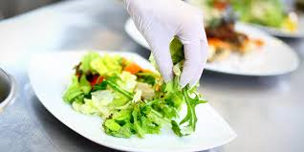](https://www.google.com/imgres?imgurl=https://triagecentral.co.uk/media/22/foodhygiene-training-S.jpg&imgrefurl=https://triagecentral.co.uk/Course/Detail/level-2-food-safety-in-catering&docid=BQkAUxswGKAHyM&tbnid=rH9NwEvHYNnLoM:&vet=10ahUKEwiP4qb6wJXgAhVMVBUIHX0tCygQMwiWAShNME0..i&w=1130&h=565&itg=1&bih=777&biw=1600&q=level%202%20food%20hygiene&ved=0ahUKEwiP4qb6wJXgAhVMVBUIHX0tCygQMwiWAShNME0&iact=mrc&uact=8)